Pupil premium strategy statement – Aston Manor Academy

This statement sets out the school strategy to support pupil premium students at Aston Manor Academy. The Academy is situated in an area of high deprivation and we recognise that many of our children have barriers that the school needs to address in order for our students to achieve as well as many other children. We aim for all disadvantaged children to be equipped to enter the next stage of education or work as well as any child from any other school. Aston Manor Academy has a relentless focus on achievement for all of our children.
Detail | Data
Number of pupils in school | 1019  751 Pupils KS3 and 4  268 KS5
Proportion (%) of pupil premium eligible pupils | 583 pupils (78%)  Out of 751 pupils
Academic year/years that our current pupil premium strategy plan covers (3 year plans are recommended – you must still publish an updated statement each academic year) | 2022/23 to 2025/26
Date this statement was published | Dec 2024
Date on which it will be reviewed | Sept 2023/24/25
Statement authorised by | J Sweeney  Headteacher
Pupil premium lead | N Turner  Deputy Headteacher
Governor / Trustee lead | Nicola Watts

Funding overview
Detail | Amount
Pupil premium funding allocation this academic year | £ 511,647.50
Pupil premium funding carried forward from previous years (enter £0 if not applicable) | £0
Total budget for this academic year  If your school is an academy in a trust that pools this funding, state the amount available to your school this academic year | £ 511,647.50

Part A: Pupil premium strategy plan

Statement of intent
At Aston Manor Academy we have an exceptionally high % of disadvantaged pupils at 78%. We also know that those students who do not qualify for pupil premium are in just as much need and we therefore aim to provide all of our children with as much access to quality teaching and learning and extensive learning opportunities. We class all of our children as being disadvantaged. In fact, there is not a significant difference between the performance of pupil premium and non-pupil premium students. Although some pupils are not in receipt of pupil premium funding we find that we support these pupils just as much through resources, uniform and support with trips etc.
- Objectives:
We aim for all of our pupils to aim high both in their academic world and their personal development. We aim for our pupils to compete with other pupils in the wider world and to achieve as well as non-pupil premium students. We set higher academic targets than national average for all students in order to encourage our students to aim high, and this is effective in pushing our students to obtain the best grades they can.

We aim to improve attendance for our targeted pupil premium students. There are many reasons why students do not attend and some of these are connected to cost of living pressures, we aim to ensure as many of students attend school every day in order that they have access to quality teaching and learning.

We understand that it is not always possible for our parents to provide our students with trips and visits to expand our students knowledge and understanding of culture, art and the wider world. We aim to give our students access to a wide range of extra-curriculum experiences to not only support their personal development but to enable them to have access to greater opportunities when they leave school. Aspiration is the key to success and this is what we try to inspire.

Our current plan shoes that our pupil premium students achieve well in comparison with local and national data (please see tables below). We have expanded our enrichment offer which gives pupils wider experiences of culture, employment, and self-awareness.

Challenges
This details the key challenges to achievement that we have identified among our disadvantaged pupils.
Challenge number | Detail of challenge
1 | Attendance is positive in school, however our SEMH pupils have lower attendance, that we believe is exacerbated by cost of living issues, and lack of access to professional support.
2 | Our pupils have less assess to wider opportunities outside of their local area and we therefore want to expose our children to the wider world and further experiences.
3 | Due to less levels of education from parents and less access to high level written materials at home our students lack developed language skills as they move into KS4. We want to increase students academic vocabulary, and improve reading age.
4 | To improve the progress and attainment of our higher attaining students – lack of access to opportunities means that our pupils are often the first to go to University
5 | To improve overall progress and attainment of all disadvantaged students – Pupils can experience many barriers and lack access to tools to support learning, e.g local library and access to books and IT, access to key adults/mentors to lead them through an academic route to higher ed/apprenticeshipis and beyond.

Intended outcomes
This explains the outcomes we are aiming for by the end of our current strategy plan, and how we will measure whether they have been achieved.
Intended outcome | Success criteria
To improve attendance of pupil premium students with a key focus on KS4 students | We will improve Year 10/11 attendance to national average and improve persistent absence in these year groups.
To increase the number of enrichment opportunities for all children across the school to raise aspirations | All children, in every group will have exposure to at least 6 enrichment opportunities every academic year.
To develop further teaching and learning strategies to improve use of academic language for pupil premium students | The Year 7/8 reading programme will increase rate of improved reading ages in KS3.  Staff medium term plans will focus on literacy – encouraging greater subject specific vocabulary usage.
To improve the progress of our higher attaining students | The HAP strategy will improve the attainment of HAP students to meet at least national average levels and raise aspirations

.Activity in this academic year
This details how we intend to spend our pupil premium funding this academic year to address the challenges listed above.

Teaching (for example, CPD, recruitment and retention)
Budgeted cost: £ 281,000
Activity | Evidence that supports this approach | Challenge number(s) addressed
Reading programme accelerated reader to be extended in Year 7 and 8 | Accelerated reader programme is well established in improving the reading ages of those pupils taking part | 3.
Higher number of staff in maths/English/Science depts for higher staff to pupil ratio to improve quality of feedback | Increased staff to pupil ratio, leading to more effective feedback for students. | 3 & 4.
Enrichment activities and wider opportunities | Wider access to quality enrichment experience such as theatre visits, university visits and meaningful encounters with employers in the workplace will widen the horizons of our students. | 2 & 4.
Music enrichment | Free music lessons for students, and access to extra member of staff for music access at lunchtimes | 2 & 5.
Increased number of reading books purchased to ensure all Year 7 students have their own reading book | Access to quality reading materials will improve vocabulary and reading age | 3.

Targeted academic support (for example, tutoring, one-to-one support, structured interventions)
Budgeted cost: £ 78,500
Activity | Evidence that supports this approach | Challenge number(s) addressed
Assertive mentoring programme for Year 11 and Year 13 students | Individual meetings with off target student to support with revision guidance and general support – one to one mentoring effective for engaging students | 1, 3, 4 & 5
Extra curricular study sessions for year 11 and 13 | Teaching staff available for extra learning and revision after school and Saturdays | 4 & 5
Brilliant club for HAP students | Access to academic trips, strategies for most able, involvement of parents, development of academic self-esteem | 4 & 5.
Training for staff on SEMH, needs of individual pupils | More awareness of strategies for individual students to support learning | 1 4 & 5

Wider strategies (for example, related to attendance, behaviour, wellbeing)
Budgeted cost: £ 160,000
Activity | Evidence that supports this approach | Challenge number(s) addressed
Employment of full time attendance manager – increased home visits, and numbers of in-school meetings | Increased communication with the school improves school understanding of issues preventing children from attending and support can be targeted for the child and family. | 1 & 5
Boxall profile purchased | Use of SEMH tool to assess the effectiveness of the provision and strategies for students | 1
Mini library in social space to enable more access to books | Students can access and take books home at any time | 3
Engagement of a counsellor and psycho-therapist through the well-being crew | Trained professionals available to support pupils who need support with mental health and well-being | 1
Rewards for attendance | Incentives to support positive pupil behaviour and attendance
Trips and visits | Expanding knowledge and understanding of British culture and high culture to support academic understanding of texts | 1 & 5
Youth worker | Key adult to support young people with positive choices who is long term and not short term, builds relationships with young people, creates stability. Can respond to common issues that young people are facing and gives them a voice. | 1 and 5
Student support fund | Support with learning resources for school and home, to help to provide students with what they need in order to learn both at home and in school

Total budgeted cost: £ 519 500

Part B: Review of the previous academic year

Outcomes for disadvantaged pupils
Performance of Disadvantage students for 2023/24

Year | Progress Gap | Attainment Gap
19/20 | +0.11 | +0.16
20/21 | +0.36 | +0.46
21/22 | -0.29 | -0.69
22/23 | +0.3 | -6.46
23/24 | +0.24 | -0.13

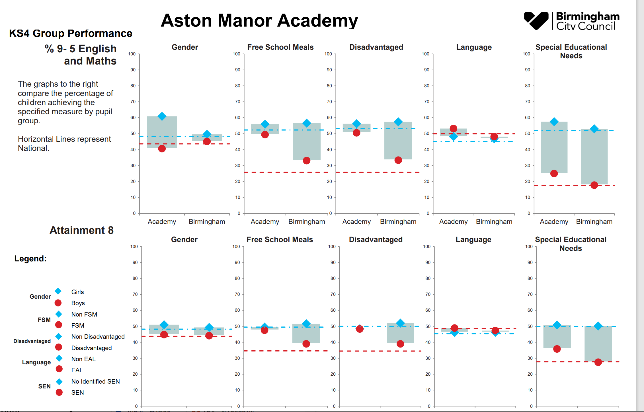
Our pupil premium students have performed well against local and national data in 2023/24 exam series, and the Academy gap is for FSM and disadvantaged is much closer than Birmingham data and National data.
Attendance data for pupil premium and non- pupil premium as of Dec 2024 is as follows:
 | Year 7 | Year 8 | Year 9 | Year 10 | Year 11 | Total
Non-pupil premium | 92.5% | 97.3% | 95.7% | 93.4% | 90.6% | 93.0%
Pupil premium | 95.2% | 94.7% | 94.8% | 92.3% | 90.1% | 93.6%

The impact of our full-time attendance manager is proving to be effective in ensuring our attendance remains in line with national average of 93% at this time. Our attendance strategy which is implemented by Heads of Year, pastoral team and attendance manager has allowed a sharper focus on individual students and strategies to support them with positive attendance to school. Our Yr 10 and 11 attendance remains the lowest in the school but has improved from 22/23.

2024 Results | KS2 Prior  Attainment | P8 | A8 | English  P8 | English  A8 | Maths  P8 | Maths  A8 | Basics  (9-5) | Basics  (9-4) | English  (9-5) | English  (9-4) | Maths  (9-5) | Maths  (9-4)
2024 Provisonal Results | 104.50 | 0.26 | 48.38 | 0.50 | 10.87 | 0.26 | 9.60 | 52.3% | 77.5% | 70.2% | 90.1% | 58.9% | 80.1%
2024 Provisonal Pupil Premium (103) | 104.00 | 0.34 | 48.33 | 0.65 | 11.01 | 0.33 | 9.61 | 50.5% | 77.7% | 70.9% | 90.3% | 58.3% | 80.6%
2024 Provisonal non-PP (48) | 104.50 | 0.10 | 48.46 | 0.20 | 10.58 | 0.09 | 9.58 | 56.3% | 77.1% | 68.8% | 89.6% | 60.4% | 79.2%
GAP | -0.50 | -0.24 | 0.13 | -0.45 | -0.43 | -0.24 | -0.03 | 5.8% | -0.6% | -2.1% | -0.7% | 2.1% | -1.4%

From our results in 2023/24 you are able to see that our pupil premium do well and perform better in most areas against non-pupil premium students.
PP data across the school -
KS3 data shows that there is no significant difference between PP outcomes and non- PP outcomes. In fact our PP students are more on track than non-PP students in Year 7 and 8.
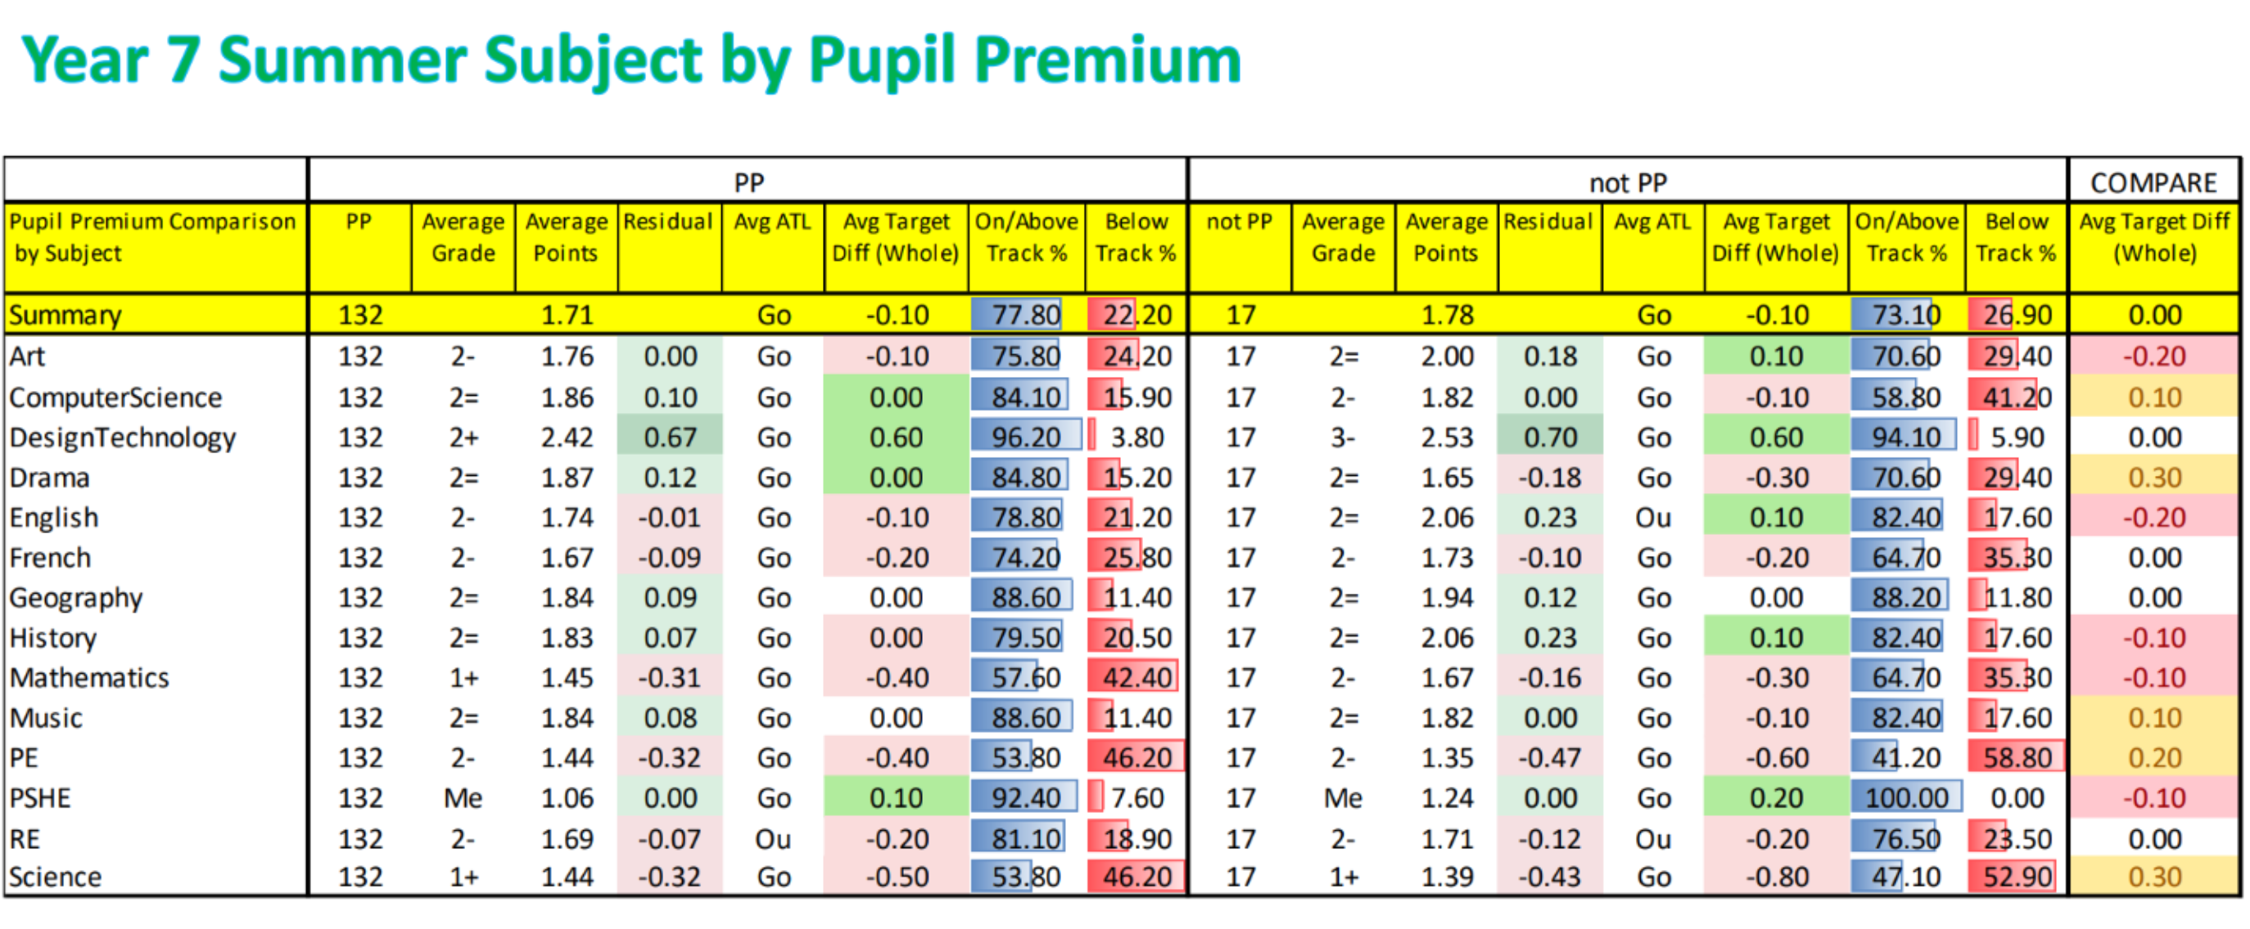

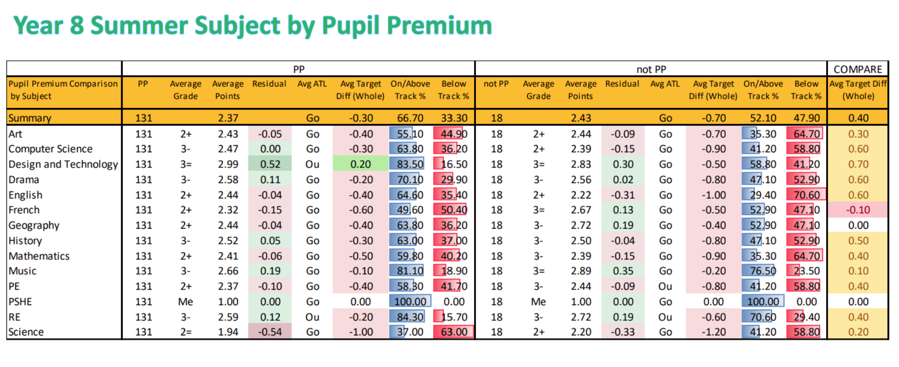

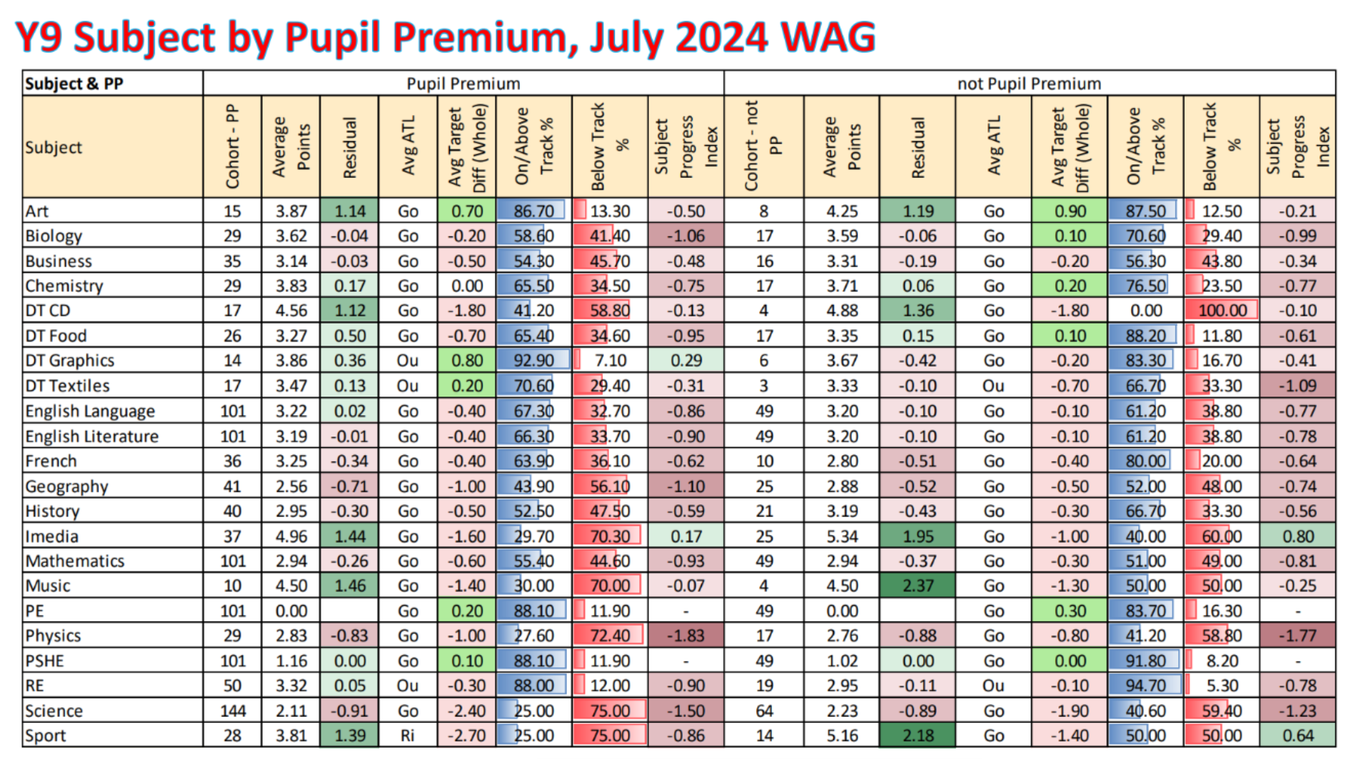
Current year 9 shows that a greater number of pupil premium students were off track in the summer term 2023.

Externally provided programmes
Please include the names of any non-DfE programmes that you used your pupil premium to fund in the previous academic year.
Programme | Provider

Service pupil premium funding (optional)
For schools that receive this funding, you may wish to provide the following information: How our service pupil premium allocation was spent last academic year
N/A
The impact of that spending on service pupil premium eligible pupils
N/A

Further information (optional)
At Aston Manor Academy we support all students as we are aware that Aston is a deprived area and there are many social issues that can impact a child’s success and achievement at school. We see that our non-pp students can be impacted more as they receive less support, as we are therefore aware that our spending needs to go where it is needed.
We have always provided our students with as much support as we can including the following:
Pizza study nights, Saturday morning revision, Saturday school for sports events, Funded Duke of Edinburgh, funded music tuition, breakfast clubs, snacks during homework club, discounts off school uniform and school trips, food bank, higher ratio of pastoral staff including youth worker, rewards trips and visits, rewards shop for achievement, visiting speakers, high quality cultural trips and visits, smaller pupil groups in KS4. These are some strategies among many others. It is a whole school approach towards pupil achievement that we believe makes the difference for any disadvantaged child at Aston Manor Academy.

